The 6th National Conference of Sport Science
on
Sport Management and Governance in the context of Ethiopia



Bahir Dar University Sport Academy in Collaboration with University Sports Association of Ethiopia (USAE) and Hope for Ethiopia (HFE)

May 25-26, 2022
Virtual Conference
Bahir Dar University, Ethiopia

Background of the Abstract


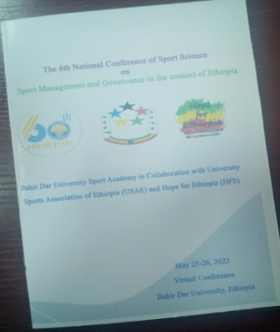
Figure 1abstract book
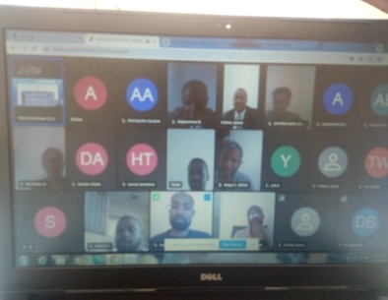
Figure 2 virtual presentation

