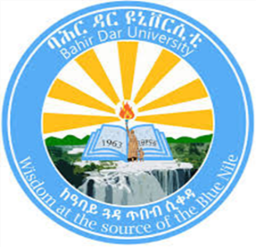

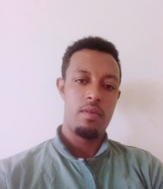

YILKAL CHALIE GETIE

Sport Academy

Sport science department

**Lecturer**

**Email**: [yilkalchalie27@gmail.com](mailto:yilkalchalie27@gmail.com)

**Phone number** +251927212061

**Date of birth**: 02 march 1989

**Academic affiliation:** Bahir Dar University

**Personal statement:** highly motivated youth sports coach, committed and consistent academic lecturer passionate about making education accessible and equitable. Over 10years of experience working with government universities, schools agencies, and youth sport projects around Ethiopia, strong belief that quality education has the power to change lives, allowing Ethiopian students to become the architects of their own life.

**Core Skills**

• Proven ability to design, prepare, and develop teaching materials

• Highly developed research qualitative and analytical skills with a strong capacity to conduct independent research

• Demonstrated ability to coach youth athletes

• Working knowledge of word, excel, power point ad statistical package for social scientists

**Academic Qualification**

2018-2019 **Master of science in Handball coaching**

Sport Academy, Bahir Dar University

Cumulative GPA 4.0

2014-2017 **Master of education (MED) in teaching physical Education**

Sport Academy, Bahir Dar University

Cumulative GPA 3.75

2008-2010 **BED in Health and Physical Education**

Sport science department, Haramaya University

Cumulative GPA 3.66

**Awards:** Best thesis award of sport academy in Bahirdar University, 2019

**Publications:** Practices and Challenges in Coaching Young Sports Trainees at Bahir Dar University Sports Academy: Sports Education and Coaching Journal **DOI:** <https://doi.org/10.31599/jces.v5i2.1443> **Volume:** 5 **Issue:** 2 **Date:** November 2024 **Pages:** 331 348Vol. 5, No.2, Nov 2024, pp. 331-348

E-ISSN: 2722-3450 P-ISSN: 2775-3808

**Conferences Attended**: 5th and 6th National Research conference on sport science, sport academy, Bahir Dar University.

**Research projects:** Amhara region’s sports development: towards to achieving the national sport policy.

Holistic evaluation and enhancement of health and physical education curriculum implementation in middle schools: a focus on the Amhara region**.**