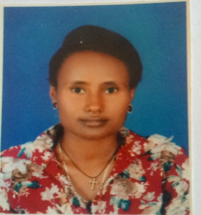

1. **Name of the staff** Hanna Tesemma Negiya

* Department Sport science
* Position/Status Lecturer
* E-mail Address htesemma@yahoo.com
* Phone 0926520209

1. **Biography**

Full name Hanna Tesemma Negya

Nationality: - Ethiopian

Date of birth, September, 1993 G.C

Sex: Female

Marital status: - married

Educational Back Ground

1-8 grade Tiya Primary School

9-8 grade – Buee high school

11-12 grade – Buee preparatory school BSC Degree in sport science - Bahir Dar university sport academy 2012-2014 G.C

MSC in Sport management – Bahir Dar University, 2016- 2017 G.C

**3 Awards and Honor**

**Academic Achievements**

From director of sport academy

From gender directorate director

**Sport Achievements**

Seventh Ethiopian university sport festival

**4. Teaching Experience**

Lecturer at Bahir Dar University Sport Academy, Bahir Dar, Ethiopia since 08/07/2014 to till date.

**5. Research interests**

I am interested

1. **Research projects since joining BDU**
2. Authored a research paper entitled “The current challenge and prospects of foot ball clubs in case of Amhara region, Bahirdar city administration ” BSc senior essay 2014.
3. Authored a research paper entitled “Assessing the financial resources and its management system on some selected Amhara region foot ball clubs ” MSc Thesis.
4. Co-Authored a research paper entitled on “Knowledge, Attitude and practices towards physical exercise and non-communicable diseases risk factors among instructors in public university and teachers education colleges of ANRS, Ethiopia ”
5. **Conferences Attended**

International research conference on sport science/every years/

**8. Publications**

#### Book

#### Journal articles

#### Book chapters

#### Published reports

#### Review articles