TITLE OF THE MANUSCRIPT
[The title of the manuscript should be all uppercase, Times New Roman, 15 pt, bold, centered; 12 pt before & 6 pt after paragraph spacing; single line spacing]
Author1^{1*}, Author2², etc.
¹ Name of University Affiliation, College or Department, State Zip-code City, P.O.Box, Country (see example below)
²Addis Ababa University, School of Mechanical Engineering, 1027 Addis Ababa, Ethiopia
*Corresponding Author: email

[Format for author’s information: Author names Times New Roman,12 pt, Affiliations: Times New Roman, 10 pt; centered; 0 pt before and after paragraph spacing; single line spacing, Centered]
ABSTRACT
[Format for ABSTRACT: Times New Roman, 11 pt; Justified; 12 pt before and 6 pt after paragraph spacing; single line spacing]
Your abstract should summarize the contents of your research. Your abstract should be one paragraph, and between 200 to 250 words. No more than 250 words are allowed.
[Format for the body of Abstract: Times New Roman, 11 pt; justified alignment; 0 pt before and 6 pt after paragraph spacing; single line spacing]
Keywords: [list 5 or 6 keywords in alphabetic here] First Keyword; Second Keyword; Third Keyword.
[Format for Keywords: Times New Roman, 11 pt; left alignment; 12 pt before and 6 pt after paragraph spacing; single line spacing]

Introduction
[Format for first heading: Use a numbering system starting with 1; All uppercase; Times New Roman, 13 pt, bold, left; 12 pt before and 6 pt after paragraph spacing; single line spacing]
Right below Keywords and before the first heading (i.e., INTRODUCTION), you need to insert a Continuous Section Break [located under Page Layout in Microsoft Word] and change the layout format to a 2-column with 0.25” (0.635cm) margin layout.
[Format for body text: No indentation; Times New Roman, 11 pt, justified alignment; 0 pt before and 6 pt after paragraph spacing; single line spacing]

LITERATURE REVIEW
You need to write at least a paragraph under the first heading before using a subsection. You can use as many subheadings as you like, but you need to number them appropriately.
We adopt the Harvard Citation Style Guide. Several examples of the Harvard citation can be found here (https://libguides.murdoch.edu.au/,Harvard referencing /all) or read this if you use Mendeley https://www.mendeley.com/guides/Harvard referencing -citation-guide/

A Subsection samples
[Format for second heading: Use a numbering system starting with .1; Capitalize Each Word; Times New Roman, 12 pt, bold, left alignment; 12 pt before and 6 pt after paragraph spacing; single line spacing]
Continue to use the 2-column layout until you want to insert figures and/or tables. To change the layout from two-column to one-column, you will insert a Continuous Section Break [located under Page Layout], change the format to one column, and then insert your figure/table below the Section Break.
Sample Heading (Third Level). Only the two levels of heading should be numbered. Lower-level headings remain unnumbered; they are formatted as run-in headings.
Sample heading (fourth level). There should be no more than four levels of headings in the submission. A summary of all heading levels may be seen in Table 1
All tables and figures must have a corresponding caption. The table caption must be placed above the table and the figure caption should be placed below the figure. Try to keep your whole table on the same page. If you must split your table, must be sure that you include a table heading to the second half of the table too. Right below your table/figure, change your layout back to the 2-column with 0.25” format.
I have inserted Table 1 This is a Simple Example of a Table and Figure 1 This is a Sample Figure to demonstrate what the layout with table/figure should look like. If possible, it is also a good idea to include the source of the figure right below the figure caption. Do not hyperlink your tables or figures in the body text

Table 1. Table captions should be placed above the tables. (Font size of table is 10, times new roman, left aligned)
Heading level | Example | Font size and style
Title (centered) | Cotton production | 15 points, bold
1st-level heading | 1 introduction | 13 points, bold
2nd-level heading | 2.1 cotton value chain | 12 points, bold
3rd-level heading | Run-in heading in bold. Text follows | 11 points, bold
4th-level heading | Lowest level heading. Text follows | 11-point, italic
Equations. Displayed equations are centered and set on a separate line. use equations on Microsoft word
K/S = (1-R)²/2R (1)
Where K is absorption and S scattering coefficients, and R is the reflectance value at the maximum absorption wavelength.
Figure. Figure should be placed at center; 12 pt before and 6 pt after paragraph spacing; single line spacing and if figure contain Figure X A and Figure XB, it should place with left alignment; 12 pt before and 6 pt after paragraph spacing; single line spacing (See example below)

Figure 1. This is a Sample Figure (times new roman, 11 fonts, Centered)
Source: https://eitex.bdu.edu.et/CTA-2023/

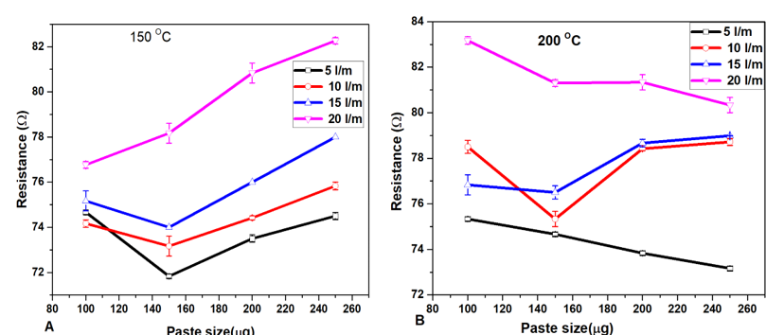

Figure XX. this is as ample of figure (A). and this is sample of figure (B).

METHODOLOGY
Clearly present the materials, equipment, chemicals used, and the methods followed to conduct your study in this section. All the machine settings, processing conditions, and data collection and analysis methods should be presented in a clear manner. All the tests performed and the standard testing method with a brief testing procedure should be presented in this section.

Text Formatting and Margin
We need to use a normal margin setting for the conference proceeding. In case the setting was different, change the margins of the whole document to normal. To do so, go to the Margins setting, change Multiple pages: to Normal. All top, bottom, left, and right margins will be 2cm.
3.1.1. Text Formatting and Margin (Sub heading, new times roman, 11 fonts, justified, bold, 0 pt before and after paragraph spacing; single line spacing)
We need to use a normal margin setting for the conference proceeding. In case the setting was different, change the margins of the whole document to normal. To do so, go to the Margins setting, change Multiple pages: to Normal. All top, bottom, left, and right margins will be 2cm.

RESULTS AND DISCUSSION
Present your major findings and discussions in this section. Cite references within the text based on APA citation style.

CONCLUSION
Make sure that you end your paper with a Conclusion or Summary or Recommendations section.
Acknowledgements
The authors would like to give special thanks to institution or a person or an organization which support and material sponsorship for this study.
Funding: Funder address if any/ or No funding
Institutional Review Board Statement: If any
Data Availability Statement: if any
Declarations: if any conflict of interests or/ not.
REFERENCES
[Format for References: Times New Roman, 11 pt; 0 pt before and after paragraph spacing; single line spacing; numbered bullets. Use Harvard referencing style

Reference List Example

Books
Author(s) Last name, First Initial(s). (Year) Title of the book. Edition (if not first). Place of publication: Publisher.
Example:
Smith, J. (2020) Introduction to Computer Science. 2nd edn. London: Oxford University Press.

Journal Articles
Author(s) Last name, First Initial(s). (Year) 'Title of article', Journal Name, Volume(Issue), Page numbers. DOI (if available).
Example:
Brown, P. and Taylor, R. (2019) 'The impact of AI on modern businesses', Journal of Business Technology, 15(2), pp. 134-150. doi:10.1234/jbt.2019.0456.

Websites
Author(s) Last name, First Initial(s). (Year) 'Title of webpage', Website Name. Available at: URL (Accessed: Day Month Year).
Example:
Williams, K. (2021) 'Understanding climate change', BBC News. Available at: https://www.bbc.com/news/climate (Accessed: 10 February 2025).

Conference Papers
Author(s) Last name, First Initial(s). (Year) 'Title of paper', in Editor(s) Last name, First Initial(s). (ed(s).) Conference Title. Place of conference, Date of conference. Place of publication: Publisher, Page numbers.
Example:
Johnson, L. (2023) 'Advancements in quantum computing', in Smith, D. (ed.) Proceedings of the International Quantum Computing Conference. Berlin, 5-7 June 2023. New York: Springer, pp. 45-60.

Reports
Author(s) Last name, First Initial(s) or Organization Name (Year) Title of Report. Report number (if applicable). Place of publication: Publisher.
Example:
World Health Organization (2022) Global Health Report 2022. Geneva: WHO.

The page length should between 5-15 pages
NB:

