CURRICULUM VITAE

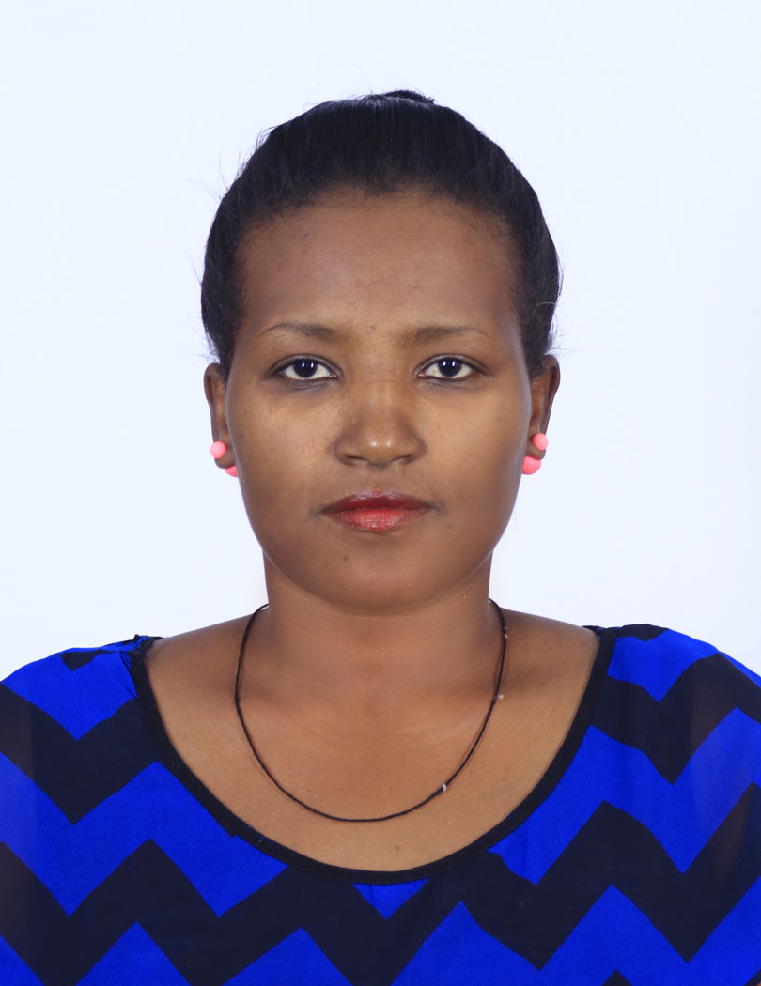

PERSONALINFORMATION
Simegn Kassa
Lecturer at Bahir Dar University
Department of Social Anthropology
Gender Female
Date of Birth 23/02/1982
Date of Birth Bahir Dar, Ethiopia
Marital status Married
Nationality Ethiopian
Address Simegn Kassa
P. O. Box 79 , Bahir Dar, Ethiopia
Mobile: +251 912344926
E-mail: simuti@yahoo.com OR sisminek2@gmail.com
- EDUCATION
MA in Sociology, India, Osmania University, 2012
MA in Linguistics, Chennai, India,Annamalia University, 2012
BE.D in English, Bahir Dar University, 2007
Diploma License for Higher Professional Educator, Aksum University, 2009
Diploma: Six month correspondent course on “United Nation and International Understanding” 2012
- WORK EXPERIENCES
Since, July, 2014 Lecturer, Bahir Dar University, Department of Social Anthropology
2012 -2013 Lecturer, Aksum University, Department of Foreign Language and communication
2008_ 2010 Graduate assistant Lecturer, Aksum University, Department of Foreign Language and communication
- SOCIOLOGY TRAININGS AND EXPERIENCE
Paper Presentation:
Presented a training of personnel of various office in Bahir Dar City” On how to involve stake holder and establish taske force in improving Girl’s Education” organized on the 17th of May 2016 by the Research and Community Service Co-ordinating of office of the Social Sciences.
Presented a paper on “social network, turning point of political activity” at the National Seminar on science& Technology, Society and Development: Osmania University, Hyderabad on 28th& 29th March, 2012. (Article Published)

Poster Presentation
Presented a poster on ‘Perceptions and Practices of Rural Women on Cultivation and Consumption of Vegetables and Fruits: An Intervention for Food-Related Health Problems in Amhara Region, Ethiopia’ in the conference on Filling gaps and removing traps for sustainable resources management at the University of Kassel’s main campus from 18 to 20 September 2019 organized by Tropentag 2019 International Research on Food Security, Natural Resource Management and Rural Development, Germany. (Article Published)

Workshop:
Worked as a member of the organizing committee for The 1st National Social Anthropology Conference, which was held from 09 to 10 June 2017.
Attended a workshop on “field work-cum-PRA training program and SPSS” Conducted by Osmania university, from 1st March 2011 to 31st March a village namely Revanpally in Nalgonda, district of Andhra Pradesh, India.
Attended a workshop on “training program-cum- workshop on research and documentation skills for professional carriers in development sector” organized by the competitive examination coaching center Osmania University and Akshara Gurukulam livelihood Education Society on 9th -12th February of 2011.
- RESEARCH INTERESTS
PhD Thesis Title: culture of eating habits on rural women and their children health status. the case of Amhara region, Ethiopia
My research interest focuses on understanding the overall impacts of culture of dietary practices and eating habits on rural women and their children health status. It focuses on in what extent the society dietary practices and eating habits affects the health status of rural women and their children. The society is highly tied with social norms and values and in most cases the culture of the society is highly favored for men than women and children in their living conditions. Hence women and children especially; in rural areas are vulnerable social groups not only in dietary habits but also in all social aspects. My research integrates both qualitative and quantitative study methods in a comparative approach.
- Community service
Title: Improving Girls’ Education by Mitigation of Gender Based Violence in Bahir Dar Town
The main purpose of the project is to reduce the prevalence rate Gender Based Violence in Bahir Dar Town
Implementing agency: department of social anthropology, Bahirdar University
Specifically, the project aimed to
Advocate Girls’ rights
Create Awareness in the Community on the harmful effects of GBV
Combat the practices of GBV through networking
Rehabilitate victims through Psycho-Social support
Project period: 2013/14- 2017/18
- Personal skills and competences
Listening Speaking Reading Writing
Mother tongue(s): Amharic | Excellent | Excellent | Excellent | Excellent
Other languages-  - English Language | Excellent | Excellent | Excellent | Excellent
- Tigrigna  (local language) | Excellent | Very Good | Very Good | Excellent
- Douch | Very Good | Good | Good | Good

I hereby declare that the above written particulars are true and fair to the best of my knowledge and belief. I assure you that I will work up to your standards.
Your sincere
Simegn Kassa

