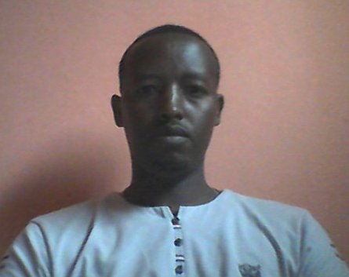
CURRICULUM VITAE
- PERSONAL INFORMATION

FULL NAME | YISMAW ASSEFA LAKEW
BIRTH PLACE | NORTH ACHEFER, LIBEN
DATE OF BIRTH | SEP. 03, 1980 E.C.
AGE | 32
SEX | MALE
MARITIAL STATUS | MARRIED
NATIONALITY | ETHIOPIAN
E- MAIL | yismawassefa2011@gmail.com
TEL | 0918146485
- EDUCATIONAL BACKGROUND

Elementary school (1-8) | Liben Elementary School (1986-1993 E.C.)
High school (9-10) | Yismala Secondary School (1994-1995 E.C.)
Preparatory school (11-12) | Merawi Secondary and Preparatory School (1996-1997 E.C.)
Higher education | Arba Minch University (1998-2000 E.C.) (BED in geography and environmental studies)
Higher education | Bahir Dare University (2004-2006 E.C) (M.A in human geography specialized in socio-economic geography)
- MAJOR QUALIFICATION

BED. in geography and environmental studies | Cumulative GPA 3.61
M.A in human geography specialized in socio-economic geography | Cumulative GPA 3.83
IV. LANGUAGE PROFICIENCY

Excellent  Very good | in reading, writing, speaking, and listening Amharic  in reading, writing, speaking, and listening English
V.BEHAVIOR

Ethical, sociable, respectful, hardworking, and ability to work with others.
VI. COMPUTER SKILLS

Computer application | Ms-Word, Ms-Excel, Ms-Power point.
VII. Work Experiences

6 years | Teaching experience both in high schools and preparatory schools
4 years | experience as Secondary and Preparatory school director
2 years | experience in teaching in a university
Total 12 years | Work Experience

